**198 Design Document**

James Potekev and Kylie Morgan

**Client Definition:**

Transportation Operators in Ontario, particularly those who suffer with attention deficiencies or Myalgic Encephalomyelitis that negatively impact their driving capabilities.

Demographic:

* 100 000 Transport Truck Operators located in Ontario[4]
* 60% of demographic is <45 years of age[1]
* 27.5% of Truck operators that experience insomnia[2]
* Average annual salary of $46 800[3]

**Competitive Landscape:**

* Operators experience symptoms of fatigue or distractedness due to long consecutive work hours of trends upwards and exceeding 12-15+ hours per day[2](Social)
* Operators are provided navigation devices for assistance, however further unbeneficial factors such as cellular devices exceeds the recommended 3 seconds maximum an operator should stray their full attention from the road, hence,furthers distracted driving[5](Technological)
* $1 876 554.79 is spent annually due to auto collisions which can be reduced with implementation of proposed design[6](Economic)

**Requirement Specifications:**

* + Device will alert user at 60-70 db [11] if they are not facing the road or
  + Experiencing early symptoms of drowsiness via heart monitor and motion detector of below 60 bpm[4]
  + Output controlled frequency of 9000RPM[13] to the user in purpose to keep them alert and focused behind the wheel
  + User will wear headpiece containing all stated components with 1 connected pulse monitor to the chest area
  + Headpiece must fit securely and comfortably on the user to ensure that devices function properly and are not distracting to the user if loose.
  + Connected to power supply(laptop)

**Design Operation:**

Microcontroller and motion sensor will be attached to the headpiece to detect motion as input data for calculations. Heart monitor will be attached to the neck/chest area to collect pulse data for calculations. Vibrating motor will be worn behind one ear as an output to alert the driver when calculated conditions are met. Audio output device to be attached to headpiece behind the other ear as output device to alert the driver when calculated conditions are met. Conditions for output activation are when the user's head is tilted outside the safe angle range for an extended period of time or when the user's heart rate drops below the safe range for an extended period of time. See mathematical/scientific specifications for specific range values.

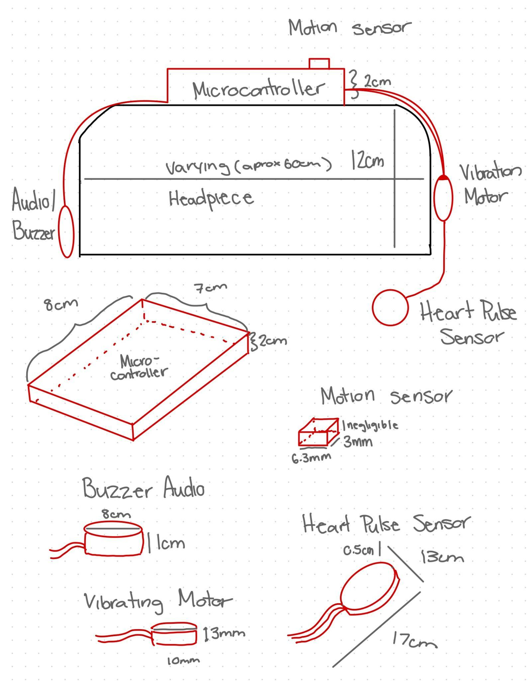

**Design Blueprints**

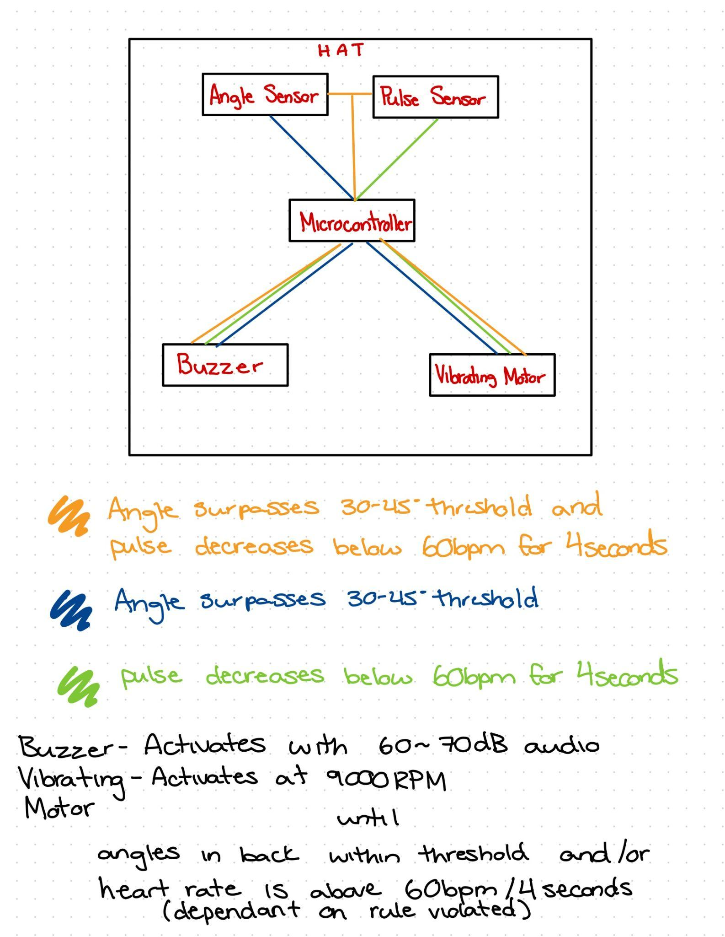

**Operations Flowchart**

**Application of scientific/mathematical principles:**

Heartbeat generation: As we cannot use a human heartbeat we must produce a fake one. Pulse sensors work by sending infrared light signals into your skin to see the expansion of your arteries as your heart pumps blood through them. To replicate this signal we will generate one using an oscilloscope to produce an artificial pulse.[17]

Power calculations: To make sure our devices can run properly we need to calculate the required power for them to run. If they do not have enough power they will not function and if they have too much power they will be destroyed. To calculate the required power for the components we must use the scientific physics principle P = V * I, where P is power, V is voltage, and I is current.

Required pulse output power:

Operating current: 55mA

Operating Voltage: 2.7-3.3V

Operating Power: P = (55mA * 2.7V) - (55mA * 3.3V) = 148.5mW - 181.5mW

Required audio buzzer output power:

Operating current: 30mA

Operating Voltage: 2-6V

Operating Power: P = (30mA * 2) - (30mA * 6V) = 60mW-180mW

Datasheet:

<https://www.vybronics.com/coin-vibration-motors/with-brushes/v-c1026b002f>

Angle calculation:

* To determine if the sensor is past the angle we must calculate this angle. The sensor takes input by reading the distance from a wall. If the head tilts then this distance will change. We will denote the initial distance from the head to the wall of the car as x. We will denote the distance from the head to the wall after the head is tilted as z. To calculate the angle(θ) we must use a trigonometric equation to calculate that the angle is θ = cos^-1(x/z)

When heart rate reaches certain beats per minute(bpm) pulse output = db:

(bpm<60)[4]=1mA[9]

*Controlled by users heart rate

Power required: 148.5mW - 181.5mW*

When motion sensor reaches a certain angle(theta), audio output = db:

(∠θ﹥33°-45°)[5]=70db [8]

*Controlled by users head motions/tendencies

Power required: 60mW-180mW*

When heart rate reaches certain beats per minute(bpm), audio output = db:

(bpm<60)[4]=70db [8]

*Controlled by users heart rate

Power required: 60mW-180mW*

When motion sensor reaches a certain angle(theta), pulse output = A:

(∠θ﹥33°-45°)[5]=1mA[9]

*Controlled by users head motions/tendencies

Power required: 148.5mW - 181.5mW*

* Data collected from head angle tilt will be recorded and if the user's head is tilted past the mathematical range considered for distracted driving for a period of time exceeding the time considered for distracted driving the output devices will activate to alert the user. Max angle for controlled driving is ~ 45 degrees. Max time before driving is considered distracted is 3-5 seconds[7].
* When head reaches required tilt angle, tilt switch will activated (with assistance of internal mechanisms due to the force of gravity (F=ma)) and activate the switch to trigger the output devices
* The output devices(audio device and vibration motor) require a certain 4.5-5.5V amount of voltage and power to activate and function at the required decibels and vibration capacity.
* Collect heart data for period for period of time: Similar to the head tilt, if your heart rate is below the minimum heart rate for a time exceeding the 4 seconds(timing validate by [5] as any movement away from the sight of the road that surpasses 4 seconds is denoted as a distraction) that is scientifically considered distracted driving, then the audio device and vibration motor will activate to alert the driver.

**Components/Manufacturing Cost:**

* **UWStore Microcontroller: $34.55[10]**

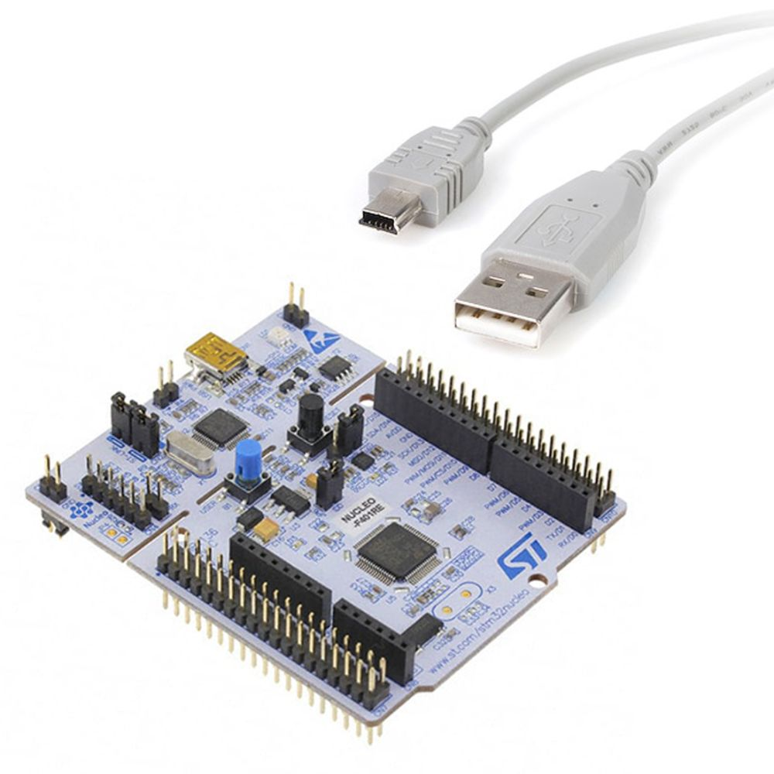

Specifications:

* MTE 241
* -8cmx7cmx2cm
* 3V operating voltage
* Nucleo-64 series ARM Cortex-M4 MCU 32-Bit Embedded Evaluation Board
* Startech 1ft USB A Male to USB Mini-B Male Cable

Geographical location: Waterloo, Ontario

* **University of Waterloo Rigidware: 4997657 Buzzer $1.85[11]**

Specifications: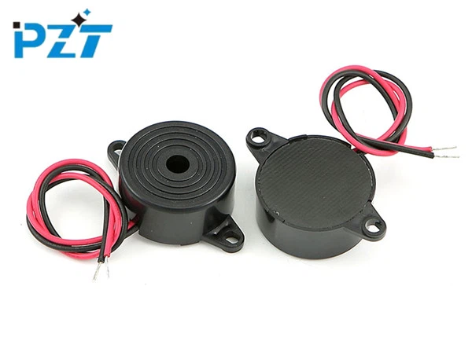

* #4997657
* 8cmx8cmx1cm
* 2-6 VDC Operating voltage
* ≤30mA Current Consumption
* 60-70 dB output

Geographical location: Waterloo,Ontario

* **Digikey Angle Sensor: $5.69[12]**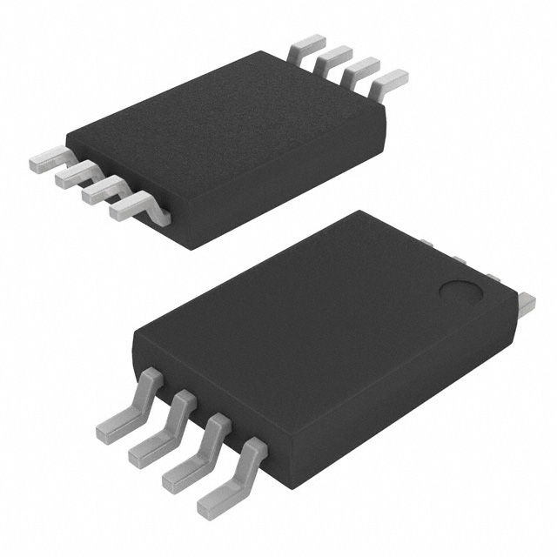

Specifications:

* A1330LLETR-T
* 6.30mmx3mm
* 4.5-5.5V voltage supply
* 360 degree capabilities

Geographical location: Thief River Falls, Minnesota

* **Amazon Wearable Heart Pulse Sensor: $17.99[16]**

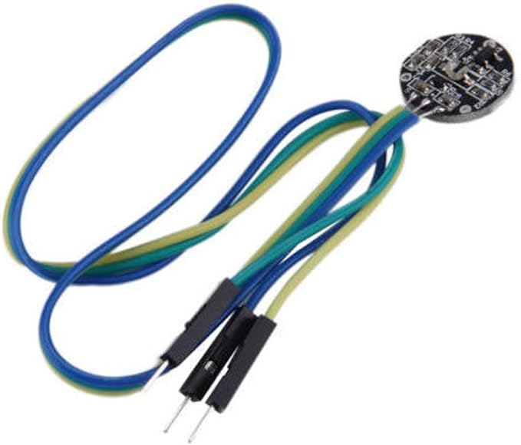

Specifications:

* MAX86174AENE+T
* 17cmx13cmx0.5cm
* Input at bps rate
* 3-4V power supply

Geographical location: DEVMO- Fort Worth, TX

Amazon Distributor- Cambridge, ON

* **Digikey Vibration DC Motor: TEK002 $4.49[13]**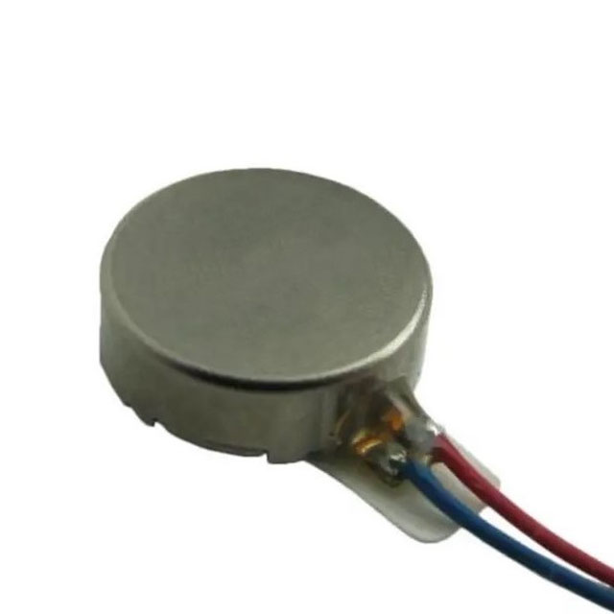

Specifications:

* VC1026B002F
* 10mmx10mmx3mm
* 9000RPM
* 3V power consumption

Geographical location: Digikey- Thief River Falls, Minnesota

* **Flat Bill Brim Adjustable Baseball Hat: $12.54[14]**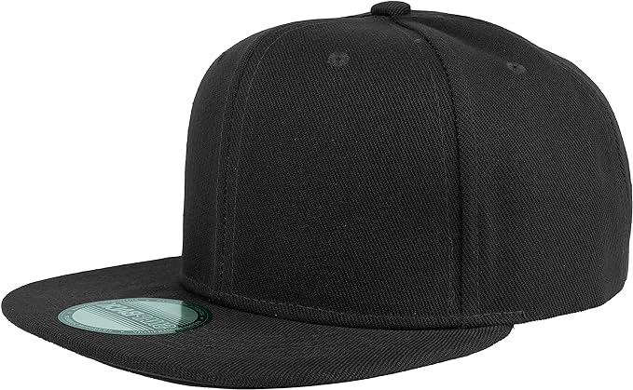

Specifications:

* (Varying diameter+7cm (brim))x12cm

Geographical location: Gelante- New York, NY

Amazon Distributor- Cambridge, ON

Total: $77.11(tax excluded)

**Implementation Cost:**

**Installation Manual:**

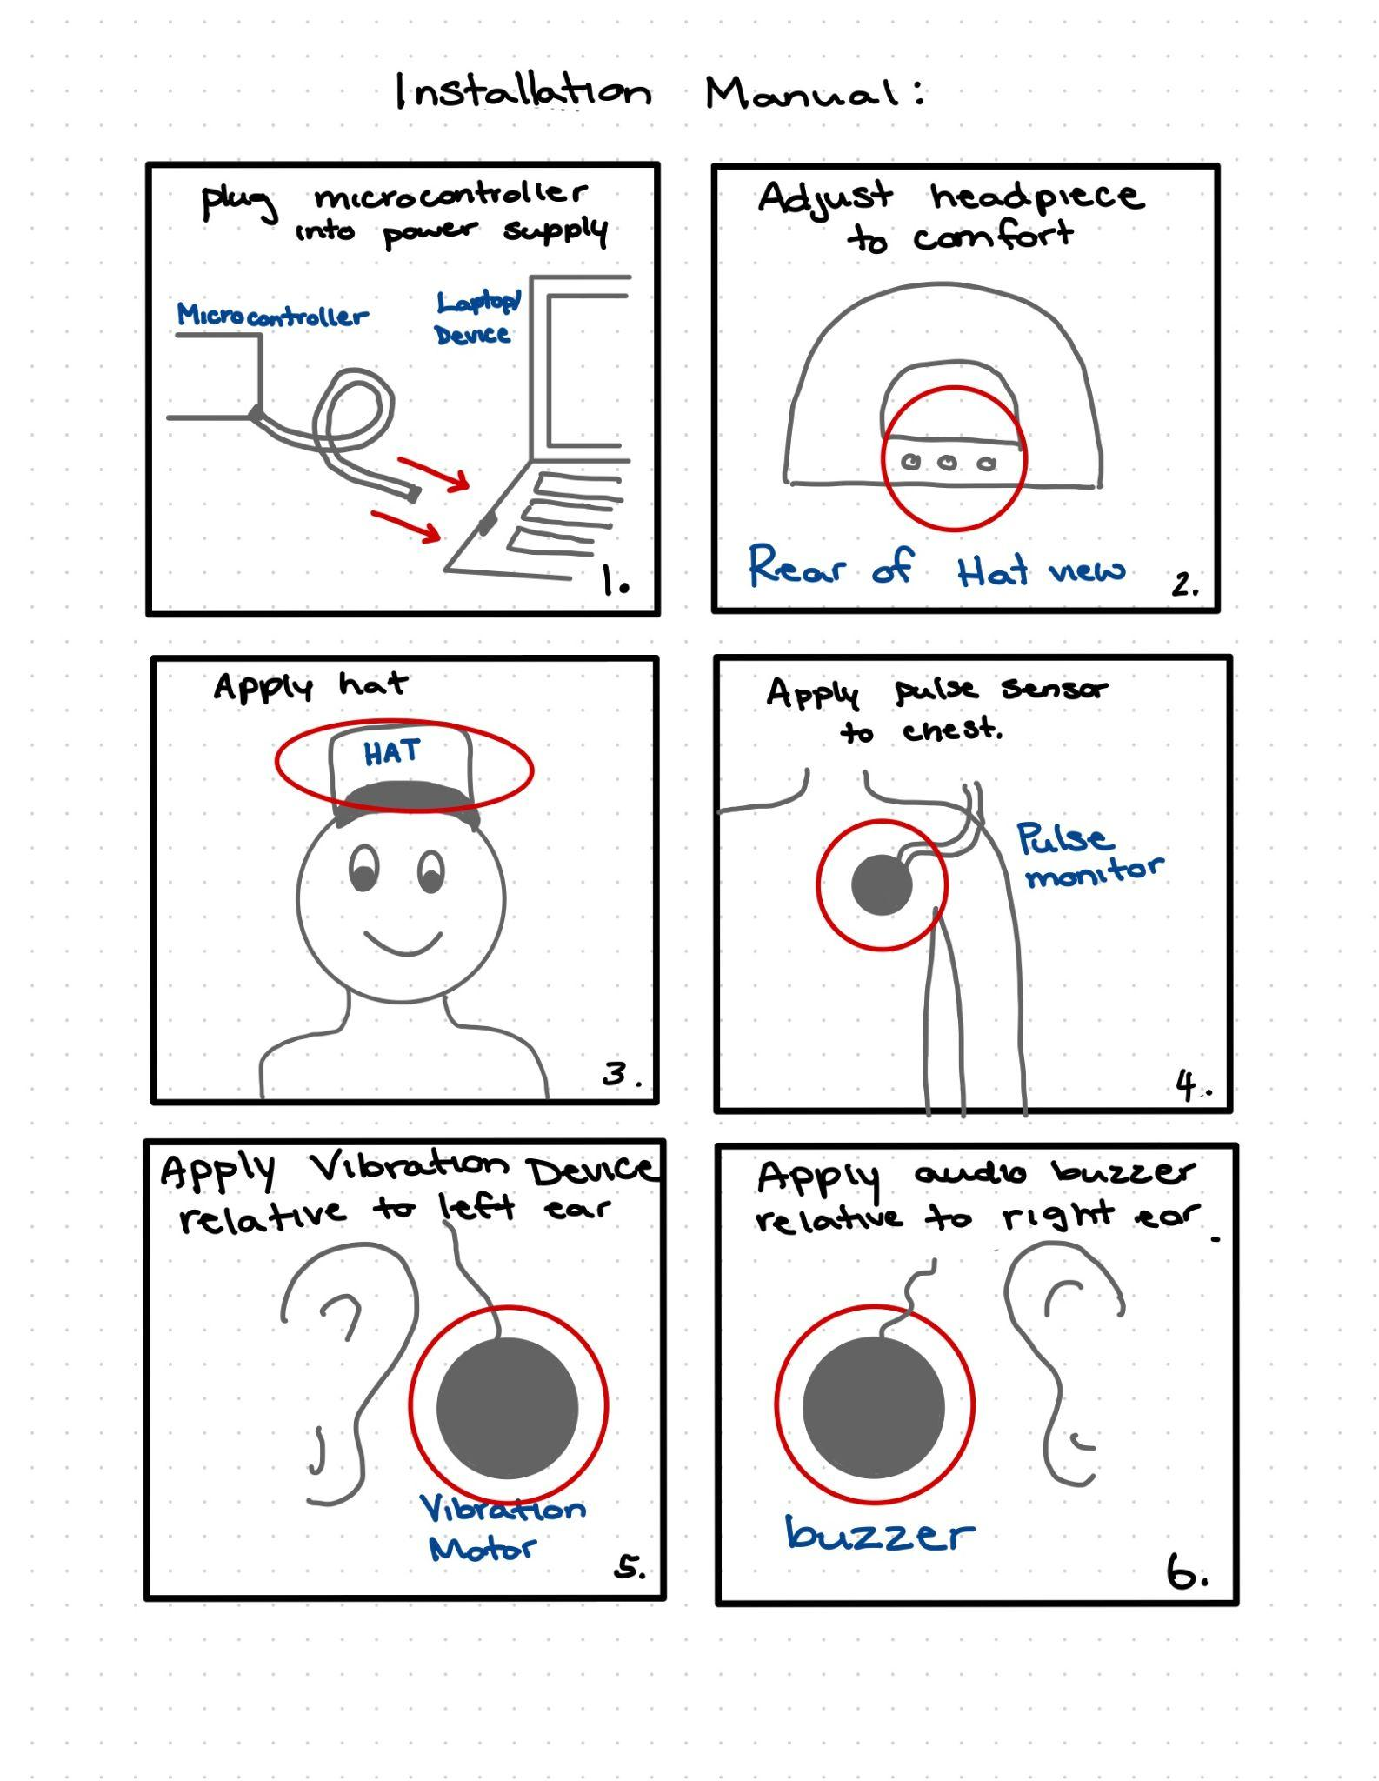

**User Guide:**

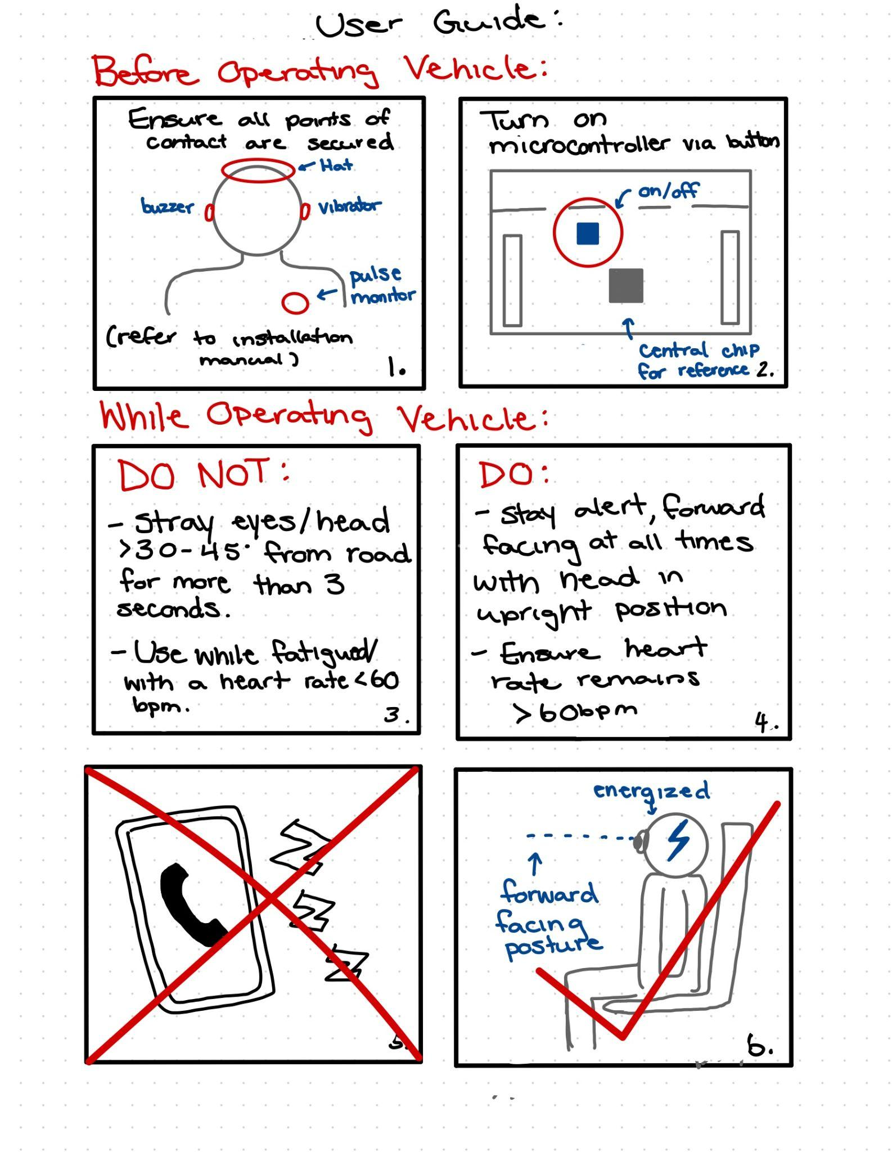

**Energy Analysis:**

Voltage Consumption:

Microcontroller:

3V + Varying supply [10[/12.7mA[15] - dependant upon components connected to central controller: V=(x1*v1 + x2*v2 + … + xk*vk) + 3Vm, x=# of attachments

Motions Sensor:

4.5-5.5V[12] - V= angle data processing supply need

Audio Buzzer:

2-6 V [11] - V= speaker output energy need

Heart sensor:

3-4V[16]- V= node sensor supply+ processing power supply

Vibration motor:

3V[13] - 9000 RPM circular motion requires more energy consumption: V=(2PiR)/T

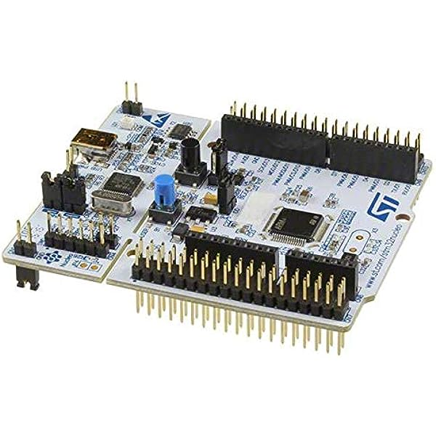

AC Power Supply Port →

(connection to power

supply via USB wire

attachment)

Total Average Voltage Required: 18.5V (adheres to energy requirements stated in outline)

Energies involved in operation:

Kinetic- Users movement to trigger output devices(buzzer/vibration)

Electrical- Voltage, amperes

Sound wave energy- buzzer output

Mechanical- heart rate/pulse output by user and processed by sensor

**Risk Analysis:**

1. Output devices are activated for an extended period of time dependent upon unforeseen circumstances. Example scenario: Vehicle collision occurs(environmental/safety hazard while using as intended)

In an event where the user activates the buzzer and vibrational motor output due to an unforeseen situation or emergency, a safeguard is in place as the output devices will automatically deactivate after 2 minutes. Without stated safeguard in place, the device will become a safety and environmental hazard as it will further distract the user and emergency responders while in state of urgency.

1. Hardware Malfunction. Example scenario: Heart sensor deattaches while in operation(safety hazard while using incorrectly)

If the heart sensor detaches from the user while in use, the input data will become zero, hence activating the buzzer and vibrational device unintentionally. To prevent this case from occurring, if the pulse input data reads zero, the output devices will not activate to prevent distractions inflicted on the operator. Otherwise the device will become a safety hazard as it will continuously distract the operator until the sensor is reapplied correctly .

1. Device improperly installed Example: sensor/headpiece applied elsewhere than desired location(safety/environmental hazard while using in unintended manner)

If the heart sensor device is applied to an area other than the chest or the headpiece containing the motion sensor is placed improperly while in range of activation(>30-45 degree), the output devices will activate for 2 minutes as a result of misuse until corrected. Otherwise result in personal safety hazard and environmental hazard as it will become a distraction to the users and those in surrounding areas. The user will also not benefit from the device's functionality resulting in increased safety risk of distracted driving the device is designed to prevent.

**Test Plan:**

**Test #1 - Tilt sensor:**

* Test setup: Place the headpiece with the tilt sensor on the mannequin head. Make sure the headpiece is secure and does not slip off or loosen from the user. Connect the device to the laptop and turn on the device.
* Environmental parameters: Given that this device is intended to be used in a vehicle and requires a nearby surface to detect distance, we must have some sort of flat surface like a piece of cardboard next to the head of the mannequin for proper functionality. As our device needs no further special parameters we will conduct our tests at standard temperature and pressure.
* Test inputs:
  + Test case 1.1: Tilt the device past the 45-degree threshold for longer than the required 4 seconds for the outputs to trigger.
* Quantifiable measurement standard: Test data will be recorded in a binary measurement standard. If the outputs trigger(on), then the test case passes the test. If the outputs don’t trigger(off), then the test case fails the test.
* Pass criteria:
  + Test case 1.1: For the first test case to pass, the outputs must trigger only after the mannequin head has been tilted past 45 degrees for longer than 45 seconds. If the outputs do not trigger after the mannequin is tilted past 45 degrees for longer than 45 seconds then the test failed.

**Test #2 - Tilt sensor:**

* Test setup: Place the headpiece with the tilt sensor on the mannequin head. Make sure the headpiece is secure and does not slip off or loosen from the user. Connect the device to the laptop and turn on the device.
* Environmental parameters: Given that this device is intended to be used in a vehicle and requires a nearby surface to detect distance, we must have some sort of flat surface like a piece of cardboard next to the head of the mannequin for proper functionality. As our device needs no further special parameters we will conduct our tests at standard temperature and pressure.
* Test inputs:
  + Test case 1.2: Tilt the device past the 45-degree threshold for less than the required 4 seconds for the outputs to trigger.
* Quantifiable measurement standard: Test data will be recorded in a binary measurement standard. If the outputs trigger(on), then the test case passes the test. If the outputs don’t trigger(off), then the test case fails the test.
* Pass criteria:
  + Test case 1.2: For the 2nd test case to pass, the outputs must not trigger after the mannequin head has been tilted past 45 degrees for less than 45 seconds. If the outputs trigger after the mannequin is tilted past 45 degrees for less than 45 seconds then the test failed.

**Test #3 - Tilt sensor:**

* Test setup: Place the headpiece with the tilt sensor on the mannequin head. Make sure the headpiece is secure and does not slip off or loosen from the user. Connect the device to the laptop and turn on the device.
* Environmental parameters: Given that this device is intended to be used in a vehicle and requires a nearby surface to detect distance, we must have some sort of flat surface like a piece of cardboard next to the head of the mannequin for proper functionality. As our device needs no further special parameters we will conduct our tests at standard temperature and pressure.
* Test inputs:
  + Test case 1.3: Tilt the device under the 45-degree trigger mark for longer than 4 seconds.
* Quantifiable measurement standard: Test data will be recorded in a binary measurement standard. If the outputs trigger(on), then the test case passes the test. If the outputs don’t trigger(off), then the test case fails the test.
* Pass criteria:
  + Test case 1.3: For the 3rd test case to pass, the outputs must not trigger only after the mannequin head has been tilted less than 45 degrees for longer than 45 seconds. If the outputs trigger after the mannequin is tilted less than 45 degrees for longer than 45 seconds then the test failed.

**Test #4 - Audio and vibrator output:**

* Test setup: Make sure the audio and vibrator outputs are each placed securely behind the ears of the user. Connect the system to the laptop and turn it on.
* Environmental parameters: No special environmental conditions are required for device functionality therefore we will conduct our tests at standard temperature and pressure.
* Test inputs:
  + Test case 2.1: The system will be tilted past the 45-degree required angle for longer than 4 seconds to trigger the audio output device.
  + Test case 2.2: The system will be tilted past the 45-degree required angle for longer than 4 seconds to trigger the vibrator output device.
* Quantifiable measurement standard: Test data will be recorded in a binary measurement standard. Either the devices turn on or they don’t.
* Pass criteria:
  + Test case 2.1: If the audio output triggers (on), then the test case passes the test. If the output doesn’t trigger(off), then the test case fails the test.
  + Test case 2.2: If the vibrator output triggers (on), then the test case passes the test. If the vibrator output doesn’t trigger(off), then the test case fails the test.

**Test #5 - Heartrate monitor:**

* Test setup: Make sure the heart rate monitor is placed securely on the user's neck. Connect the system to the laptop and turn it on.
* Environmental parameters: No special environmental conditions are required for device functionality therefore we will conduct our tests at standard temperature and pressure.
* Test inputs:
  + Test case 3.1: As we cannot use a human pulse to test the heart rate monitor, we will use the button on the STM board to input data. If the button is pressed once then the heart rate data will be read as below 60 bpm for longer than 4 seconds.
* Quantifiable measurement standard: Test data will be recorded in a binary measurement standard. Either the output devices trigger as a result of the heart rate meeting the trigger requirement, or they don’t trigger at all.
* Pass criteria:
  + Test case 3.1: If the output devices trigger after the button is pressed once, then the heart rate monitor passes the test. If the output devices do not trigger then the test case fails.

**Test #6 - Heartrate monitor:**

* Test setup: Make sure the heart rate monitor is placed securely on the user's neck. Connect the system to the laptop and turn it on.
* Environmental parameters: No special environmental conditions are required for device functionality therefore we will conduct our tests at standard temperature and pressure.
* Test inputs:
  + Test case 3.2: If the button is pressed 2 times within 3 seconds then the hearrate data will be read as below 60 bpm for less than 4 seconds.
* Quantifiable measurement standard: Test data will be recorded in a binary measurement standard. Either the output devices trigger as a result of the heart rate meeting the trigger requirement, or they don’t trigger at all.
* Pass criteria:
  + Test case 3.2: If the output devices do not trigger after the button is pressed 2 times within 3 seconds, then the test case passes the test. If the output devices do trigger then the test case fails the test.

To set up our device we will use a mannequin to place the headpiece on which contains the motion sensor, audio output, and pulse vibrator. The microcontroller is located directly on the headpiece while the audio and vibrator will each be placed behind 1 ear for maximum noticeability of the user. The heart monitor will be placed on the neck where the user would have it. Heart Rate sensors detect heart rates by picking up the electrical signal that your heart produces every time it beats. To mimic a heart rate we will be sending electrical signals to the heart monitor.[17]

The environment this system is intended to be used in is inside a truck on the road. When testing this device we have to simulate road conditions that drivers will encounter that could have an affect on the accuracy and reliability of this device. Common road conditions that drivers might experience are bumpy roads or sudden stops. To simulate this environment, we will lightly shake the mannequin similar to a bumpy road with the intention that the device will stay secured and the outputs will not activate in response to these conditions. Other environmental conditions will be at standard temperature and pressure.

To input data for the sensors to receive we will test the motion sensors angle tilt. To do this we will have 3 test cases. The first test will be to tilt the head of the mannequin within the safe range with the intention that movement is feasible without the outputs going off. The 2nd test will be to tilt the head outside of the safe range(more than 45 degrees) for more than 4 seconds with the intention that the sensors will pick it up and the output devices will activate. The 3rd test will be to tilt the head outside of the safe range for less than the required 4 seconds with the intention that the user may tilt their head to any direction without the output devices activating, so long as the tilt is for a sufficiently short period of time.

There are several measurements we will need to record to determine accuracy of the system. The angle of the titled head must be recorded(in degrees). We need to record the duration of time that the head is tilted(in seconds). We will also need to record the user's normal/resting heart rate(in BPM) for a reference point and the heart rate of the user while driving. We will need to measure the amplitude or magnitude of the audio output(in decibels). Finally we will need to record the vibration force(Grms in g^2/Hz) of the vibration motor.

After all the tests are performed and the results have been recorded we need to determine the success of the device and which criteria it has met. If the output devices activate after the head is tilted past 45 for more than 4 seconds or when the heart rate is below 60 bpm then the sensors and programming have passed the test. If the audio output has reached 75dB under the proper conditions then the audio device has passed the test. If the vibration motor reaches about .8 g^2/Hz then the vibrator has passed the test.

**References:**

1. [1] Trucking HR Canada. "Trucking HR Canada Fast Facts." [Online]. Available: https://truckinghr.com/wp-content/uploads/2019/09/THRC-Fast-Facts-.pdf.

2. [2] Dhillon & Houser. "How Common Is Truck Driver Fatigue?" [Online]. Available: https://www.dh-attorneys.com/blog/2021/september/how-common-is-truck-driver-fatigue.

3. [3] Talent.com. "Truck Driver Salary in Canada." [Online]. Available: https://ca.talent.com/salary?job=truck+driver#:~:text=The%20average%20truck%20driver%20salary%20in%20Canada%20is%20%2446%2C800%20per,up%20to%20%2460%2C450%20per%20year.

4. [4] Immigration.ca. "Ontario Has the Most Trucking Job Vacancies of Any Canadian Province." [Online]. Available: https://www.immigration.ca/ontario-has-the-most-trucking-job-vacancies-of-any-canadian-province.

5. [5] The New York Times. "Distracted Driving and the Auto Industry." [Online]. Available: https://www.nytimes.com/2018/09/27/business/distracted-driving-auto-industry.html#:~:text=Had%20I%20just%20become%20a,a%20time%2C%20the%20agency%20says.

6. [6] Transport Canada. "2020 Statistics: Social Costs of Collisions in Canada." [Online]. Available: https://tc.canada.ca/en/road-transportation/statistics-data/statistics-data-road-safety/2020-statistics-social-costs-collisions-canada.

7. [7] Royal Canadian Mounted Police. "Distracted Driving - Self-Assessment." [Online]. Available: https://www.rcmp-grc.gc.ca/cycp-cpcj/self-assessment-autoevaluation/dd-dv/index-eng.htm.

8. [8] Soundproofing Guide. "Decibels Level Comparison Chart." [Online]. Available: https://soundproofingguide.com/decibels-level-comparison-chart/.

9. [9] TestGuy. "How Electricity Affects Your Body." [Online]. Available: https://wiki.testguy.net/t/how-electricity-affects-your-body/114.

10. [10] University of Waterloo, "ECE 198 Kit - University of Waterloo." [Online]. Available: https://wstore.uwaterloo.ca/ece-198-kit.html.

11. [11] PiezoElements.com. "Piezo Buzzer with Wire Lead." [Online]. Available: https://www.piezoelements.com/piezo-buzzer/piezo-buzzer-self-drive/piezo-buzzer-with-wire-lead.html.

12. [12] Digi-Key Electronics. "Allegro Microsystems A1330LLETR-T Magnetic Sensors." [Online]. Available: https://www.digikey.ca/en/products/detail/allegro-microsystems/A1330LLETR-T/9674733.

13. [13] Digi-Key Electronics. "Vybronics Inc. VC1026B002F Buzzers." [Online]. Available: https://www.digikey.ca/en/products/detail/vybronics-inc/VC1026B002F/6009911.

14. [14] Amazon. "Gelante Snapback Hats for Men - Adjustable Baseball Cap." [Online]. Available: https://www.amazon.ca/Gelante-Snapback-Hats-Men-Adjustable/dp/B0CCK3QBF6/ref=sr_1_8?crid=166OJYJGQDDYA&keywords=flat%2Bbrim%2Bbaseball%2Bcap&qid=1698719270&sprefix=flat%2Bbrim%2Bbaseball%2Bhat%2Caps%2C79&sr=8-8&th=1.

15. [15] EngineersGarage. "STM32 Low Power Modes Analysis." [Online]. Available: https://www.engineersgarage.com/project-stm32-low-power-modes-analysis/#:~:text=According%20to%20datasheet%2C%20STM32%20consumes,is%20recorded%20at%2013.26%20mA.

16. [16] Amazon. "Heart Rate Monitor." [Online]. Available: https://www.amazon.ca/gp/product/B07R9JJ9WB/ref=ppx_yo_dt_b_asin_title_o00_s00?ie=UTF8&psc=1.

17. [17] Cleveland Clinic. "Heart Rate Monitor." [Online]. Available: https://my.clevelandclinic.org/health/diagnostics/23429-heart-rate-monitor.